Waterpark World

Part I: MDP Values

In the “Waterpark World” environment, an agent can move either clockwise or counterclockwise, except in 3 states where the agent must go clockwise due to the presence of a water slide. There are two states that represent being on a ladder leading up to the slide. Rewards for moving are 0, except that going down either portion of the slide gives a +2 reward (fun!) and climbing either part of the ladder has a reward of -1 (feels like work!). The agent has to move on every turn. Assume noise = 0.0 (i.e., actions are deterministic).



(a) How many distinct policies are possible for this MDP?

(b) Fill in the blank cells of this table with values that are correct for the corresponding function, discount, and state. Hint: You should not need to do substantial calculation here.

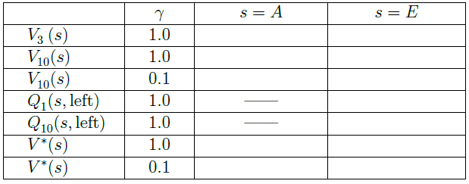

|  |  |
| --- | --- |
| 0 | 4 |
| 2 | 4 |
| 0 | 2.2 |
| 0 | 0 |
| 2 | 3 |
| Inf | Inf |
| 0 | 2.2 |

(V-ST-19-11-01. This exercise is based on an example used at U.C. Berkeley)